**Verkefni úr kafla 3.1 og 3.2**

Nafn_________________________________________ Bekkur____________________

1. Frumum er skipt í tvo flokka, hvaða flokkar eru þetta og hvað einkennir hvorn flokk fyrir sig?

____________________________________________________________________________________________________________________________________________________________________________________________________________________________________________________________________________________________________________________________________________________________

2. Hver var fyrstur til að lýsa örverum?

_______________________________________________________________________________________

3. Hver kom með hugtakið fruma (cell)

_______________________________________________________________________________________

4. Hver eru þrír hlutar frumukenningarinnar?

____________________________________________________________________________________________________________________________________________________________________________________________________________________________________________________________________________________________________________________________________________________________

5. Hvað eru ALLAR frumur með?

_____________________________________________________________________________________________________________________________________________________________________________________________________________________________________________________________________

6. Hversu stórar eru frumur? Hver er mælieining þeirra? En frumulíffæra?

_____________________________________________________________________________________________________________________________________________________________________________________________________________________________________________________________________

1. a) Hvaða gerð frumu er á myndinni? __________________________________

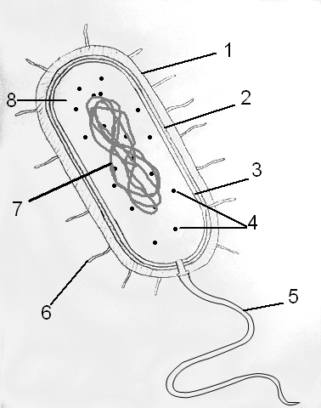b) Settu réttar tölur við rétta frumuhluta:

festiþræðir ____

frumuhimna ____

frumuveggur ____

hjúpur ____

litningur ____

netkorn (ríbósóm) ____

svipa ____

umfrymi ____

8. Berðu saman heilkjörnunga, raunbakteríur og fornbakteríur

|  |  |  |  |
| --- | --- | --- | --- |
|  | Fornbakteríur | Raunbakteríur | Heilkjörnungar |
| Frumuveggur |  |  |  |
| Frumuhimna |  |  |  |
| Kjarni |  |  |  |
| Himnubundin frumulíffæri |  |  |  |
| Ríbósóm/netkorn |  |  |  |